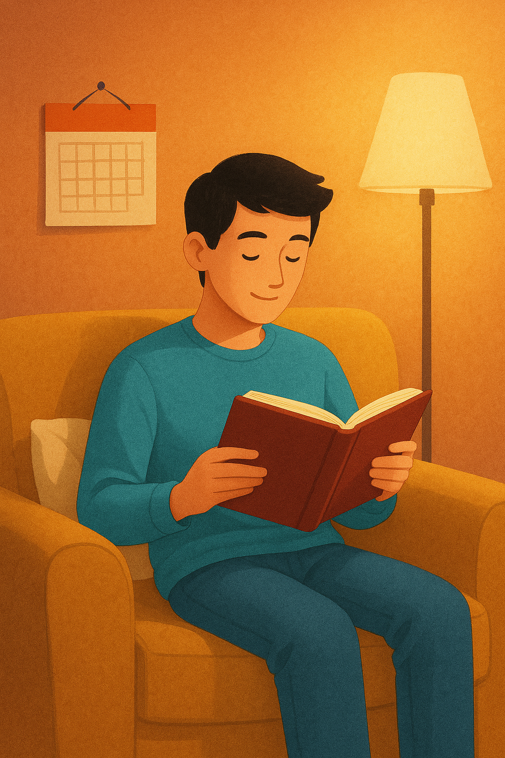

Read More in 30 Days

A Simple Plan for Busy People Who Love Books

Table of Contents
Introduction – You Are Not the Problem, Your System Is 3
Chapter 1 – Redefining What It Means to Be a Reader 5
Chapter 2 – Designing Your 30-Day Reading Window 7
Chapter 3 – Choosing the Right Books for a 30-Day Reset 9
Chapter 4 – The 30-Day Plan: Building the Habit Step by Step 11
Chapter 5 – Making Reading Compete Less with Your Phone 13
Chapter 6 – Reading with Kindness Instead of Pressure 14
Conclusion – Your Next 30 Days, and Beyond 16



Introduction – You Are Not the Problem, Your System Is

If you have ever closed your laptop at the end of a long day and thought, “I did not read a single page again,” you are not alone. Most adults who say they “should read more” are not lazy, undisciplined, or secretly uninterested in books. They are simply trying to read in an environment that is not designed for deep, focused attention.
Your phone lights up. Messages ask for quick replies. Streaming platforms suggest “just one more episode” before you even touch the remote. Even when you are physically still, your mind is being invited to jump from one small stimulus to another. In that kind of world, opening a book can feel strangely difficult, even if you love the idea of reading.
Yet the desire is still there. You remember being younger and vanishing into a story for hours. You remember that feeling of looking up from a book and realizing that time has passed and the world feels slightly different because of what you have just read. You might have a stack of non-fiction on your nightstand that you bought with the sincere intention of changing something in your life. The gap between that desire and your actual daily behavior can feel discouraging.
This guide exists to realistically close that gap. It will not demand that you wake up at 5 a.m., read fifty pages a day, or get through a book a week. It will not ask you to become a completely different person with a brand-new personality and a minimalist lifestyle. Instead, it offers a simple promise: in the next 30 days, you will build a reliable reading habit that fits the life you already have.
The core idea is that habits depend less on willpower and more on systems. When your environment, schedule, and expectations align with how your brain actually works, reading becomes much easier. When they are misaligned, even the most motivated person will struggle. This guide helps you redesign that system in small, practical steps.
You will clarify why you want to read more right now, not in some abstract “someday.” You will choose books that match your current energy rather than what you think you are supposed to like. You will create one protected daily reading window, build rituals around it, and gently learn to reduce the pull of digital distractions during that time. Instead of chasing a number of books per year, you will focus on becoming someone who naturally reaches for a book every day.
You are not trying to win a reading competition. You are trying to rebuild a relationship with books that feels grounded, enjoyable, and sustainable. The next 30 days are simply your training ground.

Chapter 1 – Redefining What It Means to Be a Reader

When adults say, “I am not really a reader,” they are usually comparing themselves to an invisible ideal. In this mental picture, a “real reader” always carries a novel, has read every classic, remembers every author’s name, and spends entire weekends lost in books without ever getting tired or distracted. Against that image, almost everyone looks inadequate.
For this 30-day reset, that definition is retired. A reader is not someone who fits a stereotype. A reader is simply someone who regularly spends time with books. That time can be short or long, daily or almost daily. It can happen with a printed book, an e-reader, or an audiobook in your ears while you walk the dog. It can be fiction, non-fiction, poetry, graphic novels, or anything else that lives between covers.
The format does not decide whether you are a reader. Your consistency does.
To make this less abstract, begin by answering three questions with brutal honesty. They do not require perfect wording, only sincerity.
The first question is why. Why do you want to read more now, in this particular season of your life? Maybe you feel mentally tired from constant scrolling and want a slower way to pay attention. Maybe you wish to grow in your career, and you know that the right non-fiction can give you the tools and ideas you need. Perhaps you miss the emotional comfort of stories and want a healthier way to unwind than television or social media.
Write down your reasons, even if they feel simple or personal. “I want to feel like my brain is still capable of focusing” is a perfectly valid reason. So is “I want to escape into other lives for a while.” Your reasons will shape the kind of books you choose and how you protect your reading time.
The second question is what. What kind of reading experience genuinely feels rewarding to you? Look back at books you have actually finished in the last years, even if the list feels short. Were they thrillers that kept you turning pages? Quiet memoirs that made you reflect on your own life? Practical manuals that showed you how to do something new? The books you have already enjoyed are better guides than any list of “must-reads.”
If your past attempts to read more were built around the wrong kind of material—dense theory when you were tired, or slow literary fiction when you craved plot—no wonder your motivation faded. You were not failing at reading. You were fighting against your own taste and attention.
The third question is when and where. What does a realistic reading session look like in your current life? Not in an ideal fantasy week with no obligations, but in an ordinary Tuesday. You may not have ninety quiet minutes in an armchair, but you might have fifteen minutes while the coffee drips, twenty minutes on the train, or a calm stretch after dinner when the house has finally settled.
Imagine yourself in those moments. Do you have enough energy to read? Can you physically place a book nearby? Do you need a lamp, a blanket, or a pair of headphones? As you answer, you begin to see how reading can fit into your routine without uprooting it.
Take a few minutes and write your answers in a notebook or a note-taking app. Do not overcomplicate it. A few honest sentences for each question are enough. This page becomes your personal “Reader’s Charter,” a quiet agreement between you and the version of yourself who wants books back in your life.
From now on, you are not trying to become someone else’s idea of a reader. You are building a reading life that is recognizably yours.

Chapter 2 – Designing Your 30-Day Reading Window

Habits become real when they attach to specific times and places. “I should read more” is a vague desire. “I read after lunch at the kitchen table for twenty minutes” is a concrete pattern that your brain can learn.
The heart of this 30-day plan is a single daily reading window. This is your non-negotiable minimum: the one moment of the day when you deliberately sit down with a book. You are free to read more whenever life allows, but this window is the anchor that keeps the habit from drifting away.
To design it, take an honest look at your days. You can even sketch a simple timeline of a typical weekday and weekend. Notice the fixed points: waking up, commuting, starting work, meals, family obligations, bedtime. Somewhere in that landscape, there are small pockets of time that go underused, often filled with aimless phone checking or waiting for the next task.
Ask yourself where your energy is more stable. Many people discover that late at night is actually the worst time to start a new habit, because exhaustion and decision fatigue are at their peak. Others find mornings too rushed but identify a quiet gap right after dinner, or right after putting children to bed. Some realize that waiting in the car before a pickup, or the first few minutes after arriving home, are surprisingly calm.
Once you identify a slot, even if it is small, treat it with respect. Name it: “This is my daily reading session.” Choose a place where you will usually be during that time. It might be the end of the couch, a specific chair, a corner of the bed, or a seat at the kitchen table. The combination of time and place forms a cue that your brain will start to recognize.
Now, give this window a little structure. Decide in advance how long you will read. For most busy adults, twenty minutes is a sweet spot. It is long enough to get absorbed in a book, short enough to feel manageable even on crowded days. If twenty minutes feels impossible right now, start with ten and allow yourself to extend later.
Prepare the space so that it quietly invites you. Put your anchor book there, already open to the right page. Add a bookmark, a lamp that gives pleasant light, and perhaps a warm drink or a glass of water. Remove obvious sources of interruption from the immediate area. You do not need a perfect “reading nook,” only a spot that feels like a small step up from the rest of your day.
Finally, make a mental agreement for the next month: for 30 days, this window has priority over low-quality distractions. You are not banning entertainment, social media, or television from your life. You are simply reserving a small daily slice of time for reading before them. Once that slice is complete, the rest of your evening is free again.
When a habit has a clear boundary in time and space, it becomes easier to respect. You are no longer negotiating with yourself every day about “if” you will read. You are only deciding “what” you will read when the familiar window opens.

Chapter 3 – Choosing the Right Books for a 30-Day Reset

Your 30-day experiment will succeed or fail largely on the back of one decision: which books you choose at the beginning. The wrong choice can make reading feel like a chore from day one. The right choice can turn your daily window into something you look forward to, even when you are tired.
For this month, think of your reading list as a set of supportive tools rather than a list of obligations. You are designing a low-friction runway, not creating a syllabus for a literature class.
Begin with your “anchor book” for the month. This is the main book you will read during your daily window. It should match the reasons you wrote down earlier. If you are craving escape and emotion, choose a novel or memoir that genuinely excites you. If you want to spark new ideas for work or personal growth, choose non-fiction that speaks directly to a question you care about.
A useful rule is this: when you hold the book or look at its cover, you should feel at least a small “pull”—a spark of curiosity, a sense that you want to know what is inside. If you feel only obligation or guilt, pick something else. The early days of rebuilding a habit are not the moment to wrestle with material that feels heavy or distant.
Next, choose a backup book for low-energy days. No matter how motivated you feel right now, there will be evenings when your concentration is thin. For those moments, it helps to have something lighter: very short chapters, essays, poems, or even a collection of short stories. Because this book demands less sustained focus, it can gently keep your habit alive when your brain is tired but you still want to honor your commitment.
Place the backup book somewhere accessible but separate from your main reading spot so you do not constantly switch between them. Think of it as an alternative route rather than a competitor.
You can also select an optional “mobile book” to live in your bag or on your phone. This might be an e-book or a slim paperback that you can pull out in waiting rooms, on public transport, or in the odd five-minute gaps that appear during the day. These stolen moments do not replace your anchored session, but they can pleasantly increase your total reading time without extra planning.
Before the 30 days begin, gather your books. Put the anchor book in your chosen reading place with a bookmark. Place the backup book where you tend to land when you are low on energy—a bedside table, perhaps. Download the mobile book to your reading app or slip it into your bag. The more steps you remove between you and the first page, the more likely you are to follow through.
Finally, give yourself clear permission to abandon a book that consistently drains you. You do not owe any title your loyalty if it dulls your curiosity or makes your reading window feel like punishment. After a fair try, you are allowed to say, “Not right now,” and move on. Protecting your enthusiasm is more important than proving that you can push through anything.

Chapter 4 – The 30-Day Plan: Building the Habit Step by Step

With your reasons clarified, your window chosen, and your books ready, it is time to walk through the next 30 days. Think of this as a simple training plan for your attention. Each week has a slightly different focus, but the central action remains steady: sit down, open the book, and read.
During the first week, your primary mission is to show up every day, no matter how briefly. Treat your reading window like brushing your teeth or taking a shower: part of the basic maintenance of your life. When the designated time arrives, you go to your chosen place, open your anchor book, and read for your minimum number of minutes. If you are distracted, you still count the session as a win as long as you kept the book open and kept bringing your attention back.
Expect your mind to resist at first. You might feel an itch to check your phone, adjust the lamp, or find a snack. That restlessness is not a sign that reading is not for you. It is simply the residue of a fast-scrolling environment. When you notice the urge to escape, label it gently—“my brain wants stimulation”—and then return your eyes to the words in front of you.
In the second week, begin to wrap a small ritual around your reading time. Rituals signal to your brain that you are transitioning from one mode to another. You might make the same cup of tea, light a candle, or play a short instrumental track while you settle into your seat. You might open your notebook and write the date with the title of the book before you start. These repeated actions become a soft bridge into focus.
By now, you will likely notice that starting feels easier than it did in week one. The habit is not yet automatic, but it is less fragile. If you miss a day because life genuinely explodes, resist the temptation to declare the experiment ruined. The next day, simply sit down again. A habit survives occasional interruptions as long as you do not attach guilt and self-criticism to them.
In the third week, you can experiment with stretching your reading time slightly on days when you feel willing. If your base is ten minutes, try fifteen. If your base is fifteen, try twenty. You do not need to extend every day. The point is to experience what it feels like to sink a little deeper into the narrative or argument, without watching the clock.
This week is also a good moment to start noticing patterns. Are there days of the week when your reading window is consistently harder to protect? Are there specific triggers that pull you away, such as certain notifications or unfinished tasks? Without blaming yourself, see if you can adjust your environment or schedule to remove one or two of those triggers.
In the fourth week, add a very brief reflection practice. After each session, take thirty seconds to capture something about what you have just read. It could be a sentence that struck you, a question that came up, or a feeling the chapter left you with. You can write this in a dedicated reading journal or in a simple note on your phone.
This small act turns your reading from a transient activity into part of an ongoing conversation with yourself. It also makes it easier to remember and apply what you read, especially with non-fiction. Over time, you will accumulate a record of your reading life: not just titles and page counts, but traces of the ideas and emotions that moved you.
By the end of day 30, you may have finished one book or several, depending on length and pace. More importantly, your brain will have experienced a full month of regularly returning to the same quiet action: sitting down with a book. That rhythm is the real achievement. Once it exists, you can choose to speed up, slow down, or change direction, but you no longer have to fight for every single page.

Chapter 5 – Making Reading Compete Less with Your Phone

In theory, the modern world offers more ways to read than ever before. In practice, the same devices that carry your e-books also constantly invite you to do anything else. You may sit down intending to read and find yourself, ten minutes later, deep in an unrelated app without quite knowing how you got there.
The goal of this chapter is not to declare war on your phone. It is to level the playing field so that books have a fair chance of holding your attention during your reading window.
Start with physical separation whenever possible. During your designated reading time, place your phone in another room, inside a drawer, or in your bag. If that is not possible, place it face down and out of reach. This sounds almost too simple, but it works because it breaks the automatic loop of “idle moment → reach for phone.” When there is a tiny bit of friction, you get a chance to remember your intention to read.
Next, look at your notifications. Many alerts are optional, yet they arrive with the same urgency as truly important messages. Choose one or two categories that you can safely mute or postpone during your reading window. You might activate “Do Not Disturb” mode with exceptions for calls from specific people, or schedule your reading time within your device's existing focus settings. The point is to protect a small island of silence, not to reject technology altogether.
If you read on a phone or tablet, experiment with a deliberate “reading mode.” Before you open your e-book app, switch to airplane mode. Tell yourself that for the next twenty minutes, this device is not a phone or a tablet; it is a book. When the session ends, you can bring the outside world back. This mental boundary helps reduce the urge to bounce between apps.
You can also recruit your phone to support your habit rather than undermine it. Set a gentle reminder that signals the start of your reading window. Use a simple timer to track your minutes so you are not tempted to check the clock repeatedly. Capture your reading reflections in a digital note if that feels easier than keeping a notebook nearby.
Over time, you may notice that your craving for quick digital hits decreases slightly, especially around your reading window. A well-chosen book provides a different kind of satisfaction: slower, deeper, and surprisingly restorative. On days when you catch yourself mindlessly scrolling, try an experiment. Pause, close whatever app you are using, and open your current book instead, just for five minutes. Often, that small pivot is enough to remind you why you are doing this in the first place.

Chapter 6 – Reading with Kindness Instead of Pressure

Books can become another arena for self-criticism. You might tell yourself that you read too slowly, that you pick “easy” titles, that you forget details, or that you never manage to finish the impressive classics on your shelf. With that kind of inner commentary, even sitting down with a book can feel like stepping into a test.
For this 30-day reset, adopt a different approach: treat reading as self-care for your mind. When you open a book, you are not auditioning for anyone’s approval. You are giving your attention a chance to stretch and breathe away from constant interruption.
This mindset shows up most clearly when things do not go according to plan. Suppose you miss two days in a row because of travel, illness, or simple chaos. The old script might say, “See, you never stick with anything,” and encourage you to give up entirely. The kinder script says, “Life was heavy. I am picking up where I left off,” and simply resumes the next day.
Equally important is how you respond to your own preferences. If you discover that you love certain genres and feel bored by others, listen to that information. There is no moral score attached to reading a page-turning mystery instead of an award-winning experimental novel. As your habit becomes stable, your tastes may naturally broaden, but you do not have to prove anything.
When you finish a book, please take a moment to acknowledge what it has added to your life. Maybe it taught you a practical technique you can apply at work. Maybe it offered a sentence that keeps echoing in your mind. Maybe it simply gave you the comfort of looking forward to your daily reading window. All of these outcomes are valuable.
You might even create a small ritual of completion. Write the date, title, and author in your journal, along with a few lines about what stayed with you. Place the book on a visible shelf or in a digital “finished” collection. This visible record combats the modern illusion that everything you consume disappears into a blur. Your reading life becomes something you can literally see growing over time.
As your habit strengthens, you will notice subtle shifts. You may find that your attention at work feels slightly more resilient. You might reach for your phone a little less automatically in quiet moments. Conversations may be enriched by ideas, stories, or examples drawn from your recent reading. None of this happens overnight, but it adds up quietly when you treat yourself with patience and respect.

Conclusion – Your Next 30 Days, and Beyond

You now have all the pieces you need for a realistic reading reset: a personal definition of what it means to be a reader, a clear daily window in your schedule, carefully chosen books that match your current energy, small rituals that ease you into focus, strategies that reduce the competition from your phone, and a kinder inner voice that measures success by showing up rather than by page counts.
The next step is not dramatic. It is simply this: when your chosen time arrives today, sit down, open your book, and read. Tomorrow, do it again. On days when you are tired, use your backup book and shorten the session if necessary, but keep the pattern alive. On days when you feel energized, linger a little longer and enjoy the feeling of being absorbed.
At some point during these 30 days, you will have a small moment of realization. You will catch yourself thinking, “This is just what I do now.” Reading will no longer feel like an unusual effort squeezed into your schedule. It will feel like one of the ways you take care of your mind in a noisy world.
After that, you can decide where to go next. You might choose longer or more challenging books. You might start a small book club or share what you are reading with a friend. You might explore new genres, revisit old favorites, or mix fiction and non-fiction in whatever ratio feels right.
Whatever you choose, remember that the hardest part—the transition from “I wish I read more” to “I read”—will already be behind you. You will have proven to yourself that you can build a meaningful reading life within the reality of your busy days, one quiet page at a time.

